Collaborative Project Report
By Olivia King

Table of Contents
Individual Context 2
Research into Companies 3
Group Formation 5
Exploration & Development of Stimulus 7
Exploration, Development & Individual Contribution 9
Evaluation & Audience Feedback 13
Sources 14

Individual Context

Through my expierience of theatre and performing arts, I have discovered that my main passion and strong skill sets include contributing and working as an actor as well as devising and directing. From the many research and experimental sessions I have personally had with theatre, I have come to love both naturalism and realism. This can be clearly seen through my devision process, and what drives me to selecting my starting point(s) and take my inspiration from when devising and performing.

Over time I hae had the privilage of attending numerous workshops such as ISTA, an internationall arts organisation that works to providing us with expierences that develop internationalism and creative learning through theatre. We are given the chance as actors to collaborate, discover and explore different forms of theatre and acting techniques with fellow thespians and amazing figures within the area of performing arts (ISTA, 2015). On more recent terms, I attented the ESF Drama Conference held at King George V school (KGV). During this conference I participated in a number of workshops set to further strenghten our foundation of physicallity and movement skills within performing. One of the workshops that took place was entirly based on physical theatre development, causing us to explore differing physical positions to convey and illustrait varying characters and situations presented by the workshop leader. I found this workshop to be highly useful when approaching the devision of the collaborative project performance as it almost forced us to think on our feet – and to physically mould ourselves into the characters presented within our exploration. I feel as though I benefitted the most through this workshop and applied a lot to my current personal characterisation and devision proccess, as physicallity within theatre along side with physical theatre in general has never really been one of my strong suits – leading me to test my limits and push myself into bringing more physicallity into my performances. Through explorations done during class, I have been yet again being given the privilage of studdying and exploring theatre practitioner Antonin Artaud and his Aurtaudian styled theatre. By utilising my on going developing skills within physicallity, I explored the darker side of theatre and Artaud’s use of theatrical elements including; lighting, sound, staging and props. In addition, I also have drawn incrediable amounts of inspiration of the darker themes presented within Artaudian theatre which allude to nightmares and frighting experiences and emotions of which audience members can relate to.

In addition to my pysical development, I had the opportunity to be apart of the school’s production of Vinegar Tom by Caryl Churchill. Through this I was able to apply my strenghts in devising, and my new found skills in physical theatre to explore the darker side of female inequality. I found that embodying my ‘mysterious’ character was significantly easier as I was able to almost open my mind and consider the different possiblities in proxemics that could be used to create a more 3D and rememberable charcater.

More closely, when it comes to devising a piece I consider my overarching strengths to mainly be consist of entering a space with an open mind and readily accepting and expanding on other's ideas. I try my best to accommodate everyone, even if that means linking all ideas together to great one overarching theme or message within the performance. In addition, I find that this skill aids me in developing my directorial skills - as I am more of the "peace keeper" among the group. I have a fascination with theatrical elements such as lighting and sound, as I truly believe these are the most essential to evolving and heightening a performance's atmosphere, and is partially the trigger for an emotional response from audience members. I often use music as inspiration for many of my ideas within performances, so incorporating them into my performance (along with sound effects) is almost effortless, as I already have the vision set in my head. I strongly feel that these personal skills will benefit my ensemble as they can possibly assist in smoothening and quickening the pace of the devision process.

Through my expierince as an artist I have found that I am greatly inspired by music. I find the different styles, and messages within differing music genres allows me to let my imagination run free and gives me the freedom and ability to explore multiple themes and messages conveyed by the artist within the song - and work it into my performance.

In terms of live performances, I have had the privilege of watching in my DP theatre journey so far, the two that have stuck with me the most and have greatly influenced my theatrical decisions as a performer would have to be "Lion Boy" by Complicite and "The Woman In Black" adapted to stage by Stephen Mallatratt from the novel by Susan Hill. This is primarily due to the theatrical and production elements utilised by both performances. Throughout the Collaborative Project performance, there is evidence of both performance natures present through the use of lighting, sound and physical movements - in addition to the over arching "dark" theme conveyed.
As briefly mentioned before, my personal context can prove to contribute to the development of this collaborative process as I aim to please and accommodate each member of the group by moulding ideas together. In addition, with my passion for music/sounds and lighting I feel this will definitely help in conveying the message and theme we choose - as I will be able to direct which lighting states should be used in order to convey specific emotions, as well as what music/sounds should be used to perfectly capture the tension and emotion within a scene.

Research into Companies
Frantic Assembly
Throughout the DP theatre course so far, my class and we have explored and studied a range of theatre styles and practitioners. This involved the exploration and experimentation with theatrical elements such as lighting, music and sound, staging, costumes and props. Each of these elements have been incooperated into our devised performances throughout the year, however recently we began exploring how others incoperate and interpret these theatrical elements and practitioner styles. This led to the exploration of theatre companies, including British theatre company Frantic Assembly.
Frantic Assembly was founded in 1994 by Scott Graham and Steven Hoggett, and is a stand out theatre company due to its nature of physicallity, unique approaches and exploration of more contemporary themes and cultures within society as well as its differing approaches to devising.
To begin this exploration we watched the performance of “Love Song”, performed by Frantic Assembly. Through watching this performance, I was able to take away the importance having a universal message present throughout the performance. I disovered how having this universal message, audience members are able to make more personal connections with the overarching issue and/or emotions present throughout a performance, thus evoking a larger emotional response and understanding of the piece. Such universal themes include the one present within Love Song; conveying universal themes revolving around recalling past experiences(memories) and the passing of time throughout one’s life.
Frantic Assembly does not seek to conform to the conventions of traditional theatre it would seem, instead they aspire to stray away from this through the employment of an unconventional physical style which combines movement, music and sound, text and design. Using these techniques, Frantic Assembly is able to devise and produce reflective, deep and meaningful performances that have direct links to contemporary culture in present day, and the effects they can have on society. As a result, Frantic Assembly is more appealing to younger audience members and those who are able to easily relate to what is being portrayed on stage.

Unlike a range of performance production companies, Frantic Assembly also offers extensive learning and 'training' programmes which can include over 6,000 participants annually. These lessons help guide individuals through the exploration of different theatre styles and culture and is explored using a variety of different methods and settings. Some of their training sessions include vocal training and educating individuals in the "building blocks to devising" a performance.

A key thing that sets Frantic Assembly apart from other theatre companies is their performance techniques. They use more physical styled acting, and they look to tell a story that educates their audience on an issue or underlying message - through the use of current and modernised situations. For example looking back at the already mentioned production "Lovesong", their use of 4 actors, 2 playing the wife and 2 playing the husband at different periods in their lives allows the audience to see the before and after effects within the characters relationships. Furthermore, Frantic Assembly is able to make performances such as Lovesong come across as more realistic and believable, despite the physical actions and movement, through the actual actors themselves; using elderly looking actors to play the "after" characters, and younger actors to play the "before" actors. This makes it extremely clear to the audience that time has changed, and so has the atmosphere, mood and problem during the given scene.

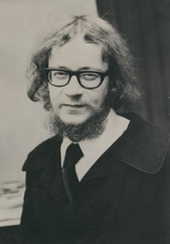
Drawing from previously studdied and explored theatre styles and practitionsers I have had the opportunity to explore throughout the DP theatre course thus far, Polish practitoiner Jerzy Grotowski who lived from 1933 to 1999 (pictured on the right), and his Poor Theatre conventions are eveidently reflected throughout much of Frantic Assembly’s work. Due to Poor Theatre’s experimental and modern nature, it can be performed in almost any space as bare as they may be. During his time, Grotowski coined the therm ‘Poor Theatre’, and used it to define a performance style that strayed away from the ‘excesses of theatre’, including detailed sets and costumes – given justification for the word ‘poor’ (Cash, 2014). Grotowski aimed for Poor Theatre to focus on the skills and strengths presented by actors. Aiding in this aim, by requiring minimal use of set pieces, props and costumes, more attention is able to be focused on the actors and the messages and themes conveyed within the piece. Frantic Assembly’s use of minmal setting, props and costumes complement this ideology nicely and cause audience members to focus more on the acting and universal messages Frantic Assembly aspires to convey.

In terms of characterisation, this is very important factor for both Frantic Assembly and Grotowski. Both believe that prepping actors for the stage was crutial part in fully embodying the characters, atmosphere and message at hand. As previously mentioned, Frantic Assbembly offers intenste training sessions for actors to aid them in the development of onstage skills, and given them the chance to explore and further develop skills in varying other theatre styles ranging from physical theatre to naturalism. Likewise, Grotowski built his theory of characterisation through the method of tiring the actors out to the point of exaustion. This was done through a range of physical activities, including running continuously for hours on end. Grotowski believed that it was at this point of fatique that actors would be able to relax and be more open to embodying characters and situations depicted onstage, giving a slight realistic element to the performance.

Key methods presented by Frantic Assembly that could possibly influence my collaborative project would be mainly the concept of a pre-show and having a universal theme. By having a pre-show, this allows us to provide more context to our performance and gives audience members a chance to almost soak in the atmosphere as opposed to just diving straight into the performance. This also gives myself and fellow actresses the chance to really mould into character, and utilise the emotion created in the atmosphere to enhance our actions on stage. In addition, by having a universal theme this allows us as performers to convey a message and/or theme that is applicable to each audience member, and something he/she can relate to. Ultimately this makes the performance easier to follow and understand for audience members, and evoking an emotional response may be significantly easier. Further more, by making our theme universal, we are able to address pressing issues within society and portray them in a new light that audience members may have never thought to view the matter in.

Group Formation
Compared to classes I have been apart of in the past, our theatre class is relatively consice consisting of just 6 members. This defnitely played a part in restricting the functionality of the group, and limited the possiblities of formation ideas for our final piece. In spite of this, we were able to come together and combinde our unique strengths and passions and make use of our restriction.
Our actors consist of 6 members:
Anna: Excels in physical movements due to her talent and passion for dance; ranging from a varaiety of contemporary styles. As a result of this, her prime contribution to the piece will be from a more physical and dance orientated stand point, choreographing various physical sequences – giving our piece the physical element it requires when drawing inspiration from Frantic Assebmly, and conveying our theme from a more abstract approach.

Chantel: Similarly to Anna, she demonstrates strenghts in the area of physicallity and movement which as a result will prove helpful in assisting in choreographic physical sequences and movements. In addition, Chantel is able to provide valid and constructive suggestions in regards to forming connections between ideas given by group members and contemporary issues. This strength is very important as it will help provide us with unity among the group as well as developing our overarching universal theme we wish to convey, inspsired by Frantic Assembly.

Kelsey: Has strengths primarily in the ablity to convey and communicate emotions and feelings through the use of gestus and facial expressions. This strength can be used to our advangage as our piece will be more physical based, and minimal in dialogue which will require actors to convey the message physically as opposed to more verbally.

Ruhi: Has strengths in direcing and devising scenes within performances, given her directorial and dictatorship skills. This will prove immensly helpful throughout the devision process as she will assist in finalising and developing the performance, as well as making sure scenes flow and incooperate elements from Frantic Assembly.

Sabrina: Much like Anna, Chantel and Kelsey, she has strengths in physical movments allowing her to move gracefully across the stage as well as convey a character profile and reflect the message of the piece. In addition she also shows a strength in facial expressions, similarly to Kelsey. This will again, make devsing an more abstract piece inspired by Fractic Assembly more achieveable.

Olivia (myself): Compared to my group counterparts, I lack in the more physical department. However, I find I make up for this in dialouge, directing and staging elements such as ligthing and music/sound effects. I have more of a strength in naturalistic and realistic theatre, as well as Aurtaudian theatre – thus resulting in the ideas I bring forward and incooperate into the piece being slightly darker and gloomier, requireing connections to contemporary issues and emotions. I have a great interest in directing as I’ll admit, I do like to assert authority and dictatorship! However, through this I am able to find the perfect balace between each of the ideas presented by my fellow thespians, that make the process enjoyable for everyone.

In terms of the roles taken thorughout the collaborative process, Anna and Chantel led more of the physical sides of the devision process – given both of their strengths in choreography and dance, resulting in excelent physical movements. Kelsey and Sabrina were able to bring further emotions into the physical sequences by assisting everyone in establishing facial expessions and gesuts that could aid us in conveying our universal theme. Seeing as both Ruhi and I show a love of directing and devision, we were able to assist in adding more naturalistic and realistic elements to the performance; including the pre-show at the begging of the piece. In addtion, we both helped round out the emotions that were aimed to be felt and express through the piece, and make sure each scene had significance and contributed in further illustrating our universal theme.

Exploration & Development of Stimulus

To initiate this proccess, each group chose our own stimulus to use as a potential basis for our piece. We had a class session where we each presented our chosen stimuls and explained why we’d chosen it, and what it represesnted to us. This idea of us all sharing and discussing stimuli was a great idea, as it gave us all the chance to share our own perspectives on each others simili as well as collectively come to a decision of which stimulus was to be used as a starting point for our piece.

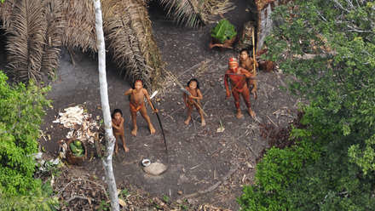
The similus that captured the attention of us all, and instantly gave us inspiration to devise a piece was the image of and undiscovered indiginous tribe Kelsey had brough in (pictured on the left). During the discussion of this, common questions that kept occuring were “how can they have gone so long undiscovered?”, “what would they have thought seeing this drone in the sky?” and most importantly we all were intriqued by the fact that we couldn’t comprehend their way of life.

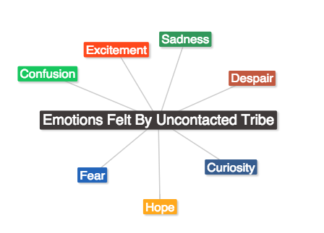
Our stimulus particularly interested me, as it is incredibly shocking to comprehend the fact that despite our ever increasing, technological and materialistic society, there are undiscovered indigenous people out there somewhere who have been unaffected by such development. Just trying to process the life these people live in comparison to ours, and what thoughts must have been running through their heads at the time the drone flew over their home. Fear? Confusion? Excitement? These are all possible feelings that could have been experienced along with many others that were brainstormed during the discussion process:

As our society is heavily influenced, and reaching the point where we rely solely on technology to survive and continue to develop our worlds - the fact that there are still untouched tribes who life in more traditional and what we would now refer to as “old fashioned” ways of living.

This particular image acted as a catalyst for my creative process as I was unable to fathom the emotions and idea(s) that there is a part of society, undiscovered and untouched by technology - and the purity of which they life in. This led me to brainstorming potential emotions that could have possibly been felt; fear, excitement, surprise, sadness, despair, loss, joy...etc. Along with my group, I came across a factor that needed to be considered when imagining untouched people; how did they communicate? What language did they speak? Surely it wouldn't be anything like english, rather something closer to an old language spoken hundreds of years ago, or a forgotten dialect? Stemming from this, we then began to discuss what out society would do to such a pure colony of people. Given our society's drive for development and advancement in all fields, testing and experimenting on these pure beings would be one of the most common results upon their discovery. With ever pressing issues such as climate change and pollution ever increasing, we are looking at ways of sustainability to prevent further damage of Earth. We have no record of how, or how long these indigenous tribes have survived and lived the way they have but one this is for certain; they have managed to go this long without knowledge of technology. This alone is a proving factor that we too can survive in such ways, as opposed to the way we currently live and continue to develop. But in order to possibly adapt (back) to this way of living, we need to understand and learn about these beings. But how can we even begin to do that without communicating with them?

Tests would be in order to examine and study how these people survive, and how they have managed to survive in extreme conditions without modern day weapons.

To begin the exploration process of this stimulus, we first devised a 30 second performance piece attempting to convey and mimic emotions and responses an individual unexposed to technology would perform. This was a challenge to do, as most of our initial responses/thoughts were fright and curiosity. Branching out from these emotions were slightly difficult, as they provided the main basis for our physical reactions i.e pointing and hiding behind objects on stage so as to shield ourselves from this 'foreign bird.' Realising that we needed to even further explore this image, we sat and had a discussion in which we took a slightly different approach and began to brainstorm the way our materialistic and technology-obsessed society would react to the footage of having discovered untouched tribes, as opposed to the other way. This made it a lot easier, as we were able to translate our own feelings towards the image - from the view point of our society.
The universal message we intended to convey was how modern day society has developed into civilisation that values scientific discoveries and advancements in technology and as result are blinded and failing in appreciating the values of life and human nature. As we advance in our technology, it is as if with every development we make we lose apart of our heritage and what it means to be human. We divert most of our attention to sustaining life for the future, and innovating ways to evolve the human race and our planet – and we forget to appreciate what we are loosing, and what was once considered every day life; nature – whether it be human, animal or plants, we are forgetting to appreciate this due to our thirst for development.

In terms of achieving this theme, we plan use utilise Frantic Assembly’s use of what is known as a pre-show. What this basically is, is a segment placed prior to the actual performance which allows for use to set the atmosphere and mood for the audience, as well as provide some context as to what they are about to witness onstage. In addition, we will use our strengths to our advantages and draw inspiration from physical theatre and choreograph sequences in conjunction with facial expressions and gestus to imbed the emotions and moods of fright, weakness and freedom as well as dominance, authority and threat throughout the piece.

Artaudian theatre, otherwise known as the Theatre of Cruelty, will also be slightly emulated throughout the piece. Given the relatively dark nature of this performance, we hope to in cooperate the idea of it being a nightmare for the ‘test subjects’ who are sought to be apart of the undiscovered (well now discovered) indigenous tribe, being held captive in a testing facility.

Initially we discussed and found it difficult to establish a target audience, however we did feel that the message would be best received by those who are more knowledgeable on the contemporary issues we face and live through today, and understand the development of our society. So, we came down the conclusion that our target audience would start from younger teenagers – so children around aged 13+. We agreed that children belonging to this age cohort would have some knowledge on civilisation, technological advancement and the possibility of undiscovered life making them the perfect youngest candidates to have seated in our audience.

To go more specifically, we aimed to have our target audience also be those who are heavily reliant on technology and contribute to the disappearance of the “old” way of living, and making way for the new. This is another primary reason why we chose ages 13+ as we believe they are the current generation that are being greatly influenced by the new creations of technology and as time goes on, paying less and less attention to the natural beauty around them.
Exploration, Development & Individual Contribution

We faced many restrictions and limitations throughout the experimentation and devision processes which led to our initial ideas being moulded and suited to accommodate our small enemble size, and lack of resources required to bring our ideas into reality. Given our groups slightly smaller size, this meant there was going to be an instant restriction on the number of differeing roles and characters we can have present within the piece. After much diliberation we established that it was important to have members double up as characters so that we could strenghten both perspectives portrayed on stage; the indigenous test subjects and the scientests.

Recalling our initial start in our process, we had another discussion regarding our starting point. Through this discussion we aimed to achieve a solid universal theme and concept we wished to radiate within the piece. We decided to drift from our initial view point of the image; which was the emotional and physical respones felt by the undiscovered tribe people, as we feeled this had been too commonly explored throughout theatre recently. Instead, we saught to explore the opposing perspective of individuals who made the disovery of these uncontacated people. From this we brainstormed how people in our society might react to this discovery, and we quickly agreed that given our society’s thirst for evloution sceintific tests and researches would most likely be conducted inorder to study these people and how they managed to survive uncontacted for so long.

In recent times, it has been predicted that in a few years time there will be a universal language spoken across the globe. As a result, this would demolish the different language we have currently, and have had in the past – causing them to just become memories and “unspoken” and “forgoten” languages, almost like Latin.

As a result, we sought to view our piece from a more futuristic perspective; in a time where technological advancements have taken over the way we life, and the earth has lost its value as we currently know it and we take approaches to disoveries from a scientific and technologic perspective as a opposed to the loving and compassionate way we should.

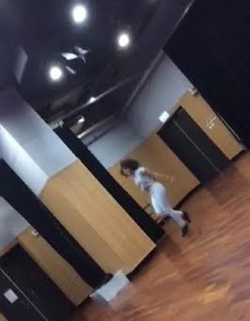
Before further devising our piece, we organised several mini workshops to complete in order to fully embody our established characters and concept of the piece. As we had spent most of our inschool-hours class sessions mainly disscussing and brainstorming themes and potential areas of interest, in order to conduct these physical workshops and experimentions we had to dedecate time outside of school hours to do so. Within this dedecated time we explored our newly discovered universal theme through Grotowski’s methods of preparing his actors; we ran around the room at different speeds for several minutes up until the point where we were exhausted and feeling fatigue. Following this we did another physical activity where an individual would call out a type of setting and situation, and the others would have to react to it and imagine they were in this location. For exmple, Anna shouted out “walking on hot coals”(pictured above). Instantly, we had to envisage hot burning coals on the floor, and adapt our movements to suit a given reaction someone walking on such a thing would be expeirencing; pain, and hopping from foot to foot to prevent the burning.

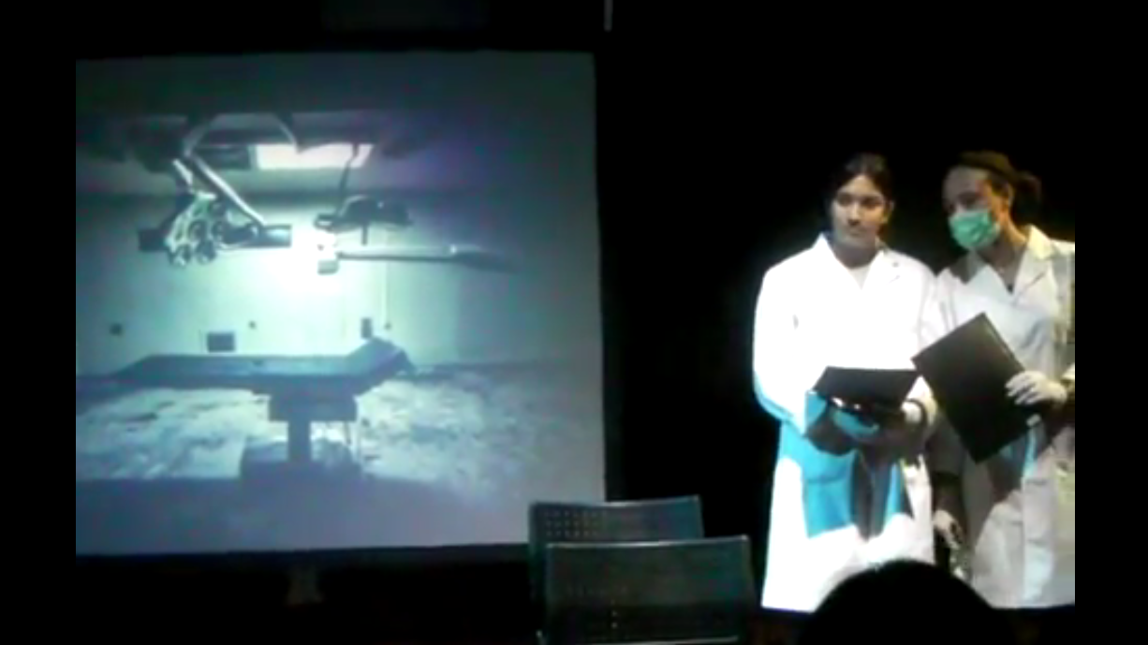
Through this Grotowski inspired exercies, we were able to apply this method of characterisation and setting of the scene by visualising the setting. In terms of our performance, our setting was a confidential sceienfitic testing facility, that echoed the feeling of industrialisation and overpowerment of technology. In order to further this line of setting ideas, we agreed to have a projection dispalyed during the pre-show and scene one of the piece(pictured on the left) This still image of a gloomy medical chair, lit harshley was projected onto the additional set piece we in cooperated into our performance; a shadow screen. This projection was intended to guide audience members into imagining they are sat in a testing facility, witnessing the testing of subjects.

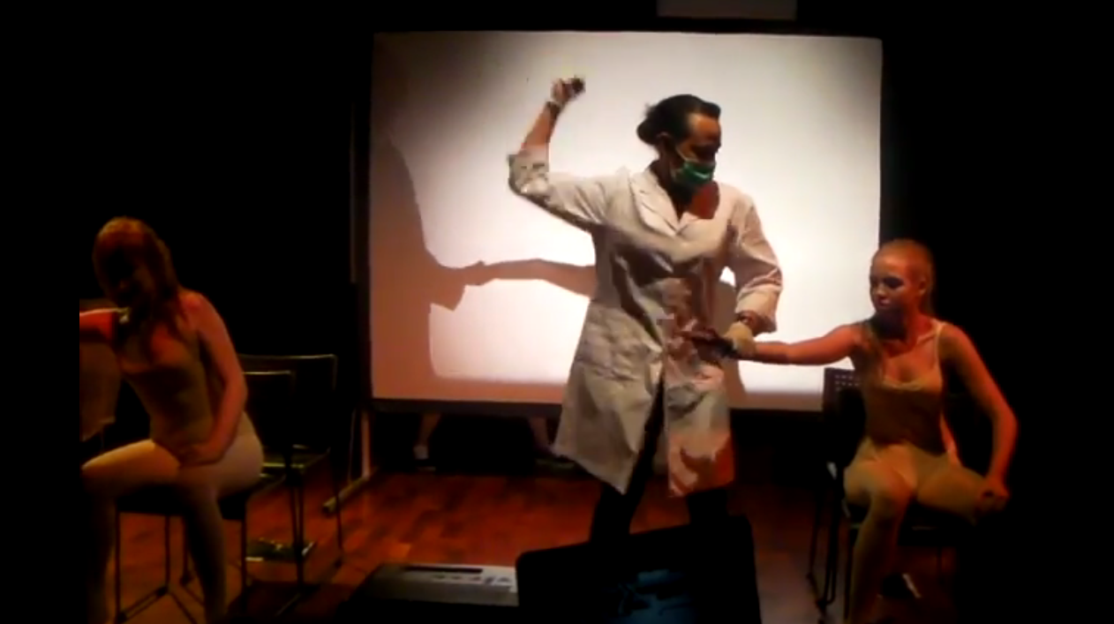
Bearing in mind the previously discussed concept of our soceitys increasing loss of compassion towards disoveries, we hoped to imbed the emotion of our approach to this disovery being cold and in some senses quite vicious. We collectively looking into conveying this idea of coldness and decided that this emotion was best suited for the clincal approach of the scientists. This would demonstraite and prove as assistance in conveying the message that modern say society has lost its compassion towards life, and sees it as mearly another test subject.

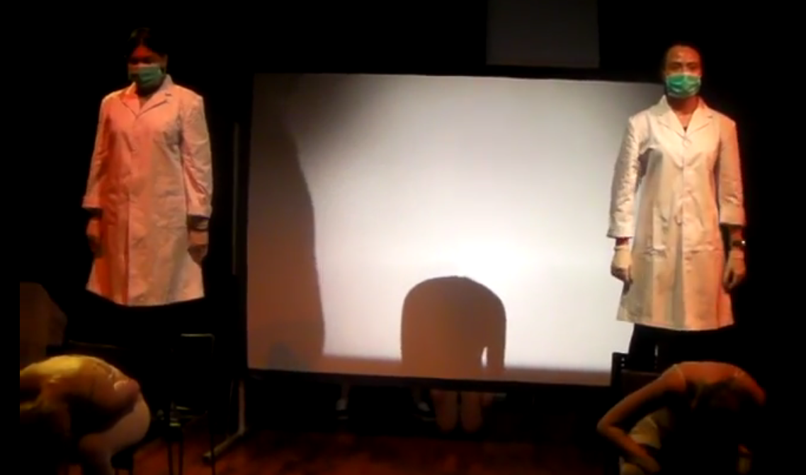
We found it a bit challenging trying to in cooperate Frantic Assembley into our piece at first, until we quickly realised that by using the concept of a pre-show was a direct performance technique they use to set the scene of their shows and provide some context. In conjunction to this, we attempted to include a ‘chair duet’ sequence within the performance. However, I realised given our limited time frame and lack of clarity between how each scene was going to go, and pointed out to the group this was too difficult to achive and perfect. Instead, we did our own version, inspired by the original style and instead of having the chairs sitauted right next to eachother, we had them approximately a metre and a half away from each other. Kelsey and Sabrina played the roles of test subjecs B and C, and sat down on the chairs in the front row – where they would mimic and emulate the style of a chair duet routine however initially beggin in time with eachother, reacting to the vigerous actions both Ruhi and I (as scientists) were forcing them to follow. This scene (2) was the introduction to the physical and abstract aspects of the piece. Not only were both Kelsey and Sabrina representing the inferiority and weakness of the test subjects, but myself and Ruhi were physically demonstraiting the abusive nature and dominance of scientist through the use of levels – as we were higher than Kelsey and Sabrina because we were stood on the chairs behind them(pictured on the right). In addition, I suggested our physical actions be a lot more rough and forcefull, suggesting scientists abusive and violent nature towards new discoveries. These brutal and heartless physical actions are evident throughout the rest of the performance through both mine and Ruhi’s characters.

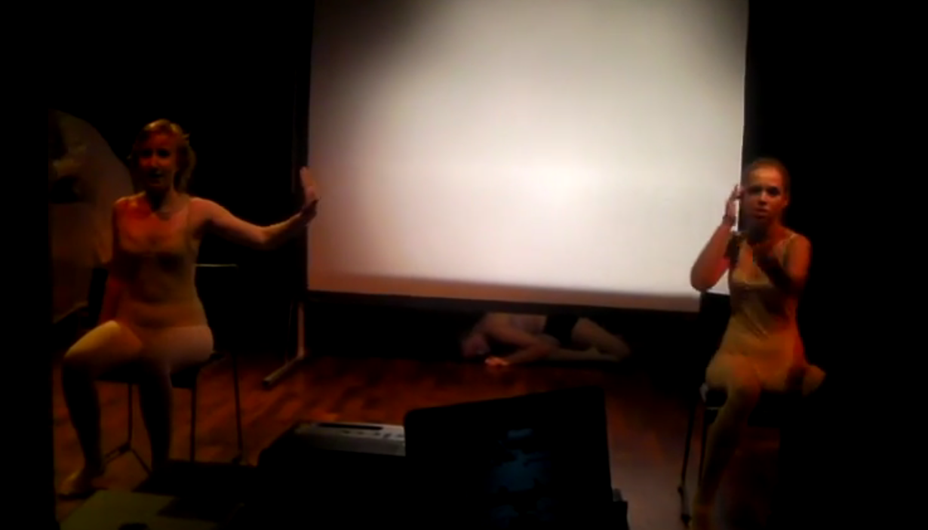
Adding to the abstract nature of our performance, we used a shadow screen. Anna was situated behind this shadow screen for majority of the first four scenes of the performance, of which she is a representitive of the mental states of the many test subject’s, mimicing the actions to do and by Kelsey and Sabrina. Advancing into scene 5, Anna’s character reacts in a different way compared to both Kelsey and Sabrina’s characters – who lash out more violently, depicted through the use of another Frantic Assembly inspired chair duet between the two characters(pictured above). She in turn is more still and appears to be more physcially controlled and uses her body to take up a small amount of space lying on stage, once again alluding the inferiority of the test subjects in the eyes of the scientists. There is a change in music, as it becomes more slow and quite compared to the fast pace and loud music played during scenes 3 and 4. Behind Anna on the shadow screens pop up two more shillouets(pictured top left). These shillouets begin fighting with one another, as one appears to be more dominant over the other. This suggests the mental struggle between the test subjects rational and irrational self.

Throughout most of the performance, I directed the music used within each scene. These ranged from eery dark music in the pre-show, to loud and faced paced music within scenes 3 and 4, to the slow eery music played in scene 5 and lastly to the lyric song played in scene 7 when Anna has been exposed to our language, thus corrupting the expeirment to discover their ways of communication without infecting ours with theirs, and she is about to share her knowledge and sense of freedom with the other test subjects. Compared to the rest of my ensemble, I didn’t run a conventional workshop like the physical Grotowski workshop. In turn I used my passion for music and led a session where I proposed various sounds and music tracks I believed would mesh with a specific scene. This process was very similar to the starting point process with the stiumuli, as it was an open discussion between the group where we established the differing emotions and messaged represented within each music track. This was very helpful for the rest of the ensemble, as by having my come to the session with a predone playlist of possible tracks to select from, this made the process significantly quicker. Most of the songs I proposed were accepted with open arms, and used in the scenes throughout the performance – which proved to myself that I had a clear understanding of the message(s) being conveyed within each scene, and the whole performance in general.

Once we had the music tracks selected, choreographing and deciding on the direction of each scene became came with ease as the music itself provided direction through its pace and occasional rapid change in tempo. Going into the devision space, I knew that music would play a key part in the performance. This was primarily because Frantic Assembly uses music and sound effects throughout their performances as support for the actions and situation occuring on stage in conjunction with the building up of the atmosphere. Bearing this in mind, having a good playlist that accurately emmulated the emotions and situations on stage would guide audience members into being fully immersed into the performance, and building a stronger connection to the universal message being portrayed.

Evaluation & Audience Feedback

I personally feel that I did a relatively sufficeint job in communicating my role effectively to the audience. Given the limited amount of run through we had prior to the final performance really proved as a set back for being able to fully embrace what was happening on stage. This was because of the constant worry I personally had that there would be a technical issue, or a scene would not go according to how it was initally devised, resulting in the performance being lost. With this all on my mind, it became a challenge to get into character. In addition, I feel that I did not do my best with dialouge. This was a shock to me, as on regular occasions I am usually very good with dialouge and it comes quite naturally. Given the fact that we had not infact entirely scripted the piece made it challenging to fluidly deliever my lines. This may have come across to audience members that I did not know my lines, and that the performance had not been properly rehearsed.

However, on a more positive not I believe that I excelled quite well in the physical aspects of the performance – which in itself is a shock to me, as I’m not the the most physical person within theatre. I found that I was able to make my actions come across as more brutal and violent, and really assert my dominance through body language and placement of my arms in a “power stance”, particularly in scenes 3 and 4. This aided both Ruhi and I in achieving our goal of symbolising and conveying to audience members that we had dominance over the test subjects – ultimately adding to the proving of our universal message.

I personally believe that our performance fufilled the intentions set in place by our ensemble; but to a certain extent. The performance as a whole felt slightly rushed, and should have been performed at a slower rate. Had it been performed slower, the audience may have understood the intended universal message more clearly – as through the feedback received from audience members, it is evident that some of it was “lost in translation”. The message of what was being experimented and tested for in the first place was lost too. This proves that we should have invested less time into devising, and devoted extra time to rehearsing and perfecting the piece.

In a lot of the feedback received, comments regarding how we needed to perfect the flow of the performance occurred frequently and how transitions between scenes could be clearer. This is understandable as I can imagine that because the performance seemed quite rushed, and transitions were not polished, the messages and situations being portrayed within each scene could get muddled up and could be an overload for audience members.

Essentially, what we can take away from this collaborative project is that we need to improver our organisational skills within the devision process, and in some cases strive to make sure our performance is not over ambitious – as our may have been, leading to a rational explanation as to why the performance was not fully received by audience members.

Sources

Building Blocks: The Frantic Method. (2015, May 16). Retrieved June 18, 2015, from https://www.youtube.com/watch?v=BC9uJrY9Bh8
Cash, J. (2014, March 12). Poor Theatre Conventions. Retrieved June 18, 2015, from http://www.thedramateacher.com/poor-theatre-conventions/comment-page-1/
Frantic Assembly: Thrilling, Energetic and Uncompromising Physical Theatre. (2015). Retrieved June 18, 2015, from http://www.franticassembly.co.uk/

ISTA: Who we are. (2015). Retrieved June 18, 2015, from http://www.ista.co.uk/who-we-are/
"Uncontacted" Tribe Seen in Amazon. (2010, October 28). Retrieved June 18, 2015, from http://news.nationalgeographic.com/news/2008/05/080530-uncontacted-tribes-photo.html

